PRENCY LELEI EXPRESS HR CONSULTANT AGENCY

CODE |  |  |  |  |  | FOR |  | DH
APPLICATION FOR EMPLOYMENT
 | EMILY NJERI KINGORA |  |  |  |  |  |  |  |  |  |  |  |  | الإسم الكامل
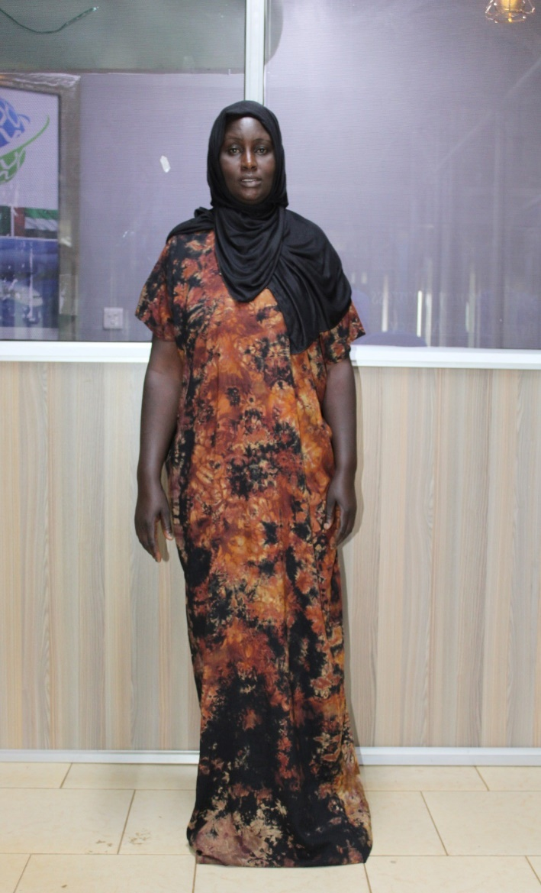 |  |  |  |  | Monthly Salary |  |  |  |  |  | 1100 |  |  | الراتب الشهري
 |  |  |  |  | Contract Period |  |  |  |  |  | Two (2) Years |  |  | مدة العقد
 |  |  |  |  | PASSPORT DETAILS |  |  |  |  |  |  |  |  |  | بيانات جواز السفر
 |  |  |  |  | Number |  |  |  |  |  | AK1177307 |  |  |  | رقم الجواز
 |  |  |  |  | Date of Issue |  |  |  |  |  | 21 JUN 2022 |  |  |  | تاريخ الصدور
 |  |  |  |  | Date of Expiry |  |  |  |  |  | 20 JUN 2032 |  |  |  | تاريخ الإنتهاء
 |  |  |  |  | Place of Issue |  |  |  |  |  | NAIROBI |  |  |  | مكان الصدور
 |  |  |  |  | LANGUAGES & EDUCATION |  |  |  |  |  |  |  |  |  | اللغة والتعليم
 |  |  |  |  | English |  |  |  | YES |  |  |  |  |  | الإنجليزية
 |  |  |  |  | Arabic |  |  |  | FAIR |  |  |  |  |  | العربية
 |  |  |  |  | Education [ Course ] |  |  |  | HIGH SCHOOL |  |  |  |  |  | المستوىالتعليمي
 |  |  |  |  | PREVIOUS EMPLOYMENT ABROAD |  |  |  |  |  |  |  |  |  | خبرة خارج البلاد
 |  |  |  |  | Period |  |  |  |  | Country of Employment |  |  |  |  | Position
 |  |  |  |  | 2 YEARS |  |  |  |  | SAUDI ARABIA |  |  |  |  | HOUSE HELP
 |  |  |  |  | PERSONAL DATA
 |  |  |  |  | Nationality |  |  |  |  |  |  |  | KENYAN |  |  | الجنسية
 |  |  |  |  | Religion |  |  |  |  |  |  |  | CHRISTIAN |  |  | الديانة
 |  |  |  |  | Date of Birth |  |  |  |  |  |  |  | 1 APR 1984 |  |  | تاريخ البلاد
 |  |  |  |  | Place of Birth |  |  |  |  |  |  |  | ELDORET WEST |  |  | مكان الميلاد
 |  |  |  |  | Living Town |  |  |  |  |  |  |  | ELDORET WEST |  |  | مكان السكن
SKILLS & EXPERIENCES العمل خبرة |  |  |  |  |  |  | Marital Status |  |  |  |  |  | SINGLE |  |  | الحالة الإجتماعية
Arabic cooking |  | NO
Baby Sitting |  | GOOD |  | عناية الرضع |  |  | No. of Children |  |  |  |  |  | 3 |  |  | عدد الأطفال
Children Care |  | GOOD |  | عناية الأطفال |  |  | Weight |  |  |  |  |  | 78KG |  |  | الوزن
Tutoring |  | GOOD |  | تعليم الأطفال |  |  | Height |  |  |  |  |  | 5’6” |  |  | الطول
Disabled Care |  | GOOD |  | عناية العجزة |  |  | Complexion |  |  |  |  |  | BROWN |  |  | لون البشرة
Cleaning |  | GOOD |  | التنظيف |  |  | Age |  |  |  |  |  | 41 |  |  | العمر
Washing |  | GOOD |  | الغسيل |  |  | PROFILE SUMMARY |  |  |  |  |  |  |  | البيانات ملخص
Ironing |  | GOOD |  | الكوي
Cooking |  | FAIR |  | الطبخ
Arabic Cooking |  | NO |  | الطبخ العربي
Sewing |  | GOOD |  | الخياطة
Computers |  | NO |  | الكمبيوتر إستخدام
Driving |  | NO |  | القيادة
Others |  | GOOD |  | خبرات أخرى |  |  | DATE |  |  |  |  | 07/01/26 |  |  |  |  | التاريخ
