 |  |  |  |  |  |  | 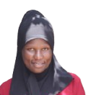
APPLICATION FOR EMPLOYMENT
FULL NAME | KABAHUMA JANNET |  |  |  |  |  |  | الإسم الكامل
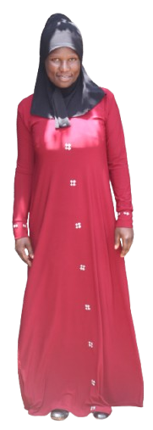 |  |  |  | Position |  | HOUSE MAID
 |  |  |  | Telephone No. |  | +256758827239
 |  |  |  | Preferred Country |  | SAUDI ARABIA
 |  |  |  | PASSPORT DETAILS بيانات جواز السفر
 |  |  |  | Passport No. |  | B00279929 |  | رقم الجواز
 |  |  |  | Date of Issue |  | 13/FEB/2024 |  | تاريخ الصدور
 |  |  |  | Date of Expiry |  | 14/FEB/2034 |  | تاريخ الإنتهاء
 |  |  |  | Place of Issue |  | KAMPALA |  | مكان الصدور
 |  |  |  | LANGUAGES & EDUCATION اللغة والتعليم
 |  |  |  | English |  | FAIR |  | الإنجليزية
 |  |  |  | Arabic |  | POOR |  | العربية
 |  |  |  | Education [Course] |  | PRIMARY |  | المستوى
 |  |  |  | PREVIOUS EMPLOYMENT ABROAD خبرة خارج البلاد
 |  |  |  | Period |  | Country of Employment |  | Position
 |  |  |  | PERSONAL DATA
 |  |  |  | Nationality |  | UGANDAN |  |  | الجنسية
 |  |  |  | Religion |  | NON-MUSLIM |  |  | الديانة
 |  |  |  | Date of Birth |  | 20/SEP/1986 |  |  | تاريخ البلاد
 |  |  |  | Place of Birth |  | KABAROLE |  |  | مكان د
 |  |  |  | Living Town |  | KIGANDA |  |  | مكان السكن
SKILLS & EXPERIENCES خبرة العمل |  |  |  | Marital Status |  | MARRIED |  |  | الحالة الإجتماعية
Baby Sitting |  | GOOD | عناية الرضع | No. of Children |  | 03 |  |  | عدد الأطفال
Children Care |  | GOOD | عناية الأطفال | Weight |  | 55KGS |  |  | الوزن
Tutoring |  | GOOD | تعليم الأطفال | Height |  | 160CM |  |  | الطول
Disabled Care |  | GOOD | عناية العجزة | Complexion |  | BROWN |  |  | لون البشرة
Cleaning |  | GOOD | التنظيف | Age |  | 39 |  |  | العمر
Washing |  | GOOD | الغسيل | PROFILE SUMMARY ملخص البيانات
Ironing |  | GOOD | الكوي | She can take good care of children and is good at doing household duties. Can clean very well and she is ready to work.
Cooking |  | GOOD | الطبخ
Arabic Cooking |  | POOR | الطبخ العربي

PASSPORT COPY

